Before or after attending an instructor-led (live) session or registering for online training, all participants must register with VIRTUS Online.  Click on this link to access the VIRTUS Registration page:  https://www.virtusonline.org/virtus/reg_2.cfm?theme=0&org=18860  Or:  Go to http://www.virtusonline.org  On the left side of the screen, click on First-Time Registrant to begin registration. To proceed, click on Begin the registration process. Select the name of your organization Richmond - Diocese (from the pull-down menu, by clicking the downward arrow and highlighting your organization). Once your organization is highlighted, click Select. | 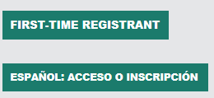  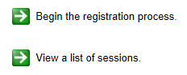
Create a User ID and Password you can easily remember.  This is necessary for all participants. This establishes your account with the VIRTUS program. If your preferred User ID is already taken, please choose another ID. We suggest the use of email addresses as usernames.  Click Continue to proceed. | 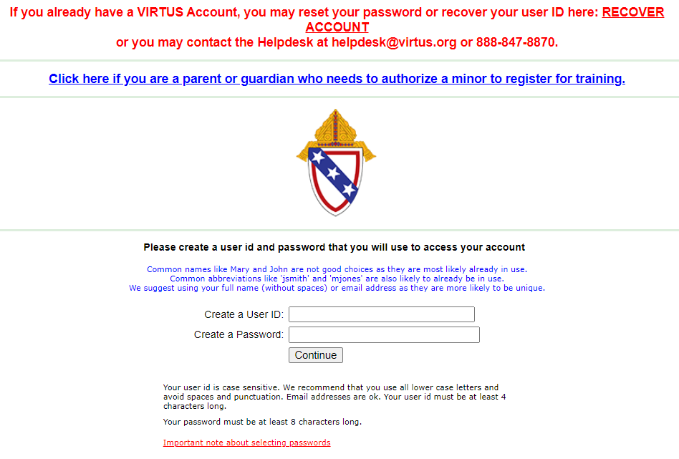
Provide all the information requested on the screen.  Several fields are required, including: First & Last Name, Email Address, Home Address, City, State, Zip, Phone Number, Date of Birth, and any Aliases.  (Note: Do not click the back button or your registration will be lost.)  Click Continue to proceed.  If you do not have an email address, consider obtaining a free email account at mail.yahoo.com, or any other free service. This is necessary for your Safe Environment Coordinator to communicate with you. If you cannot obtain an email address, enter: noaddress@virtus.org. | 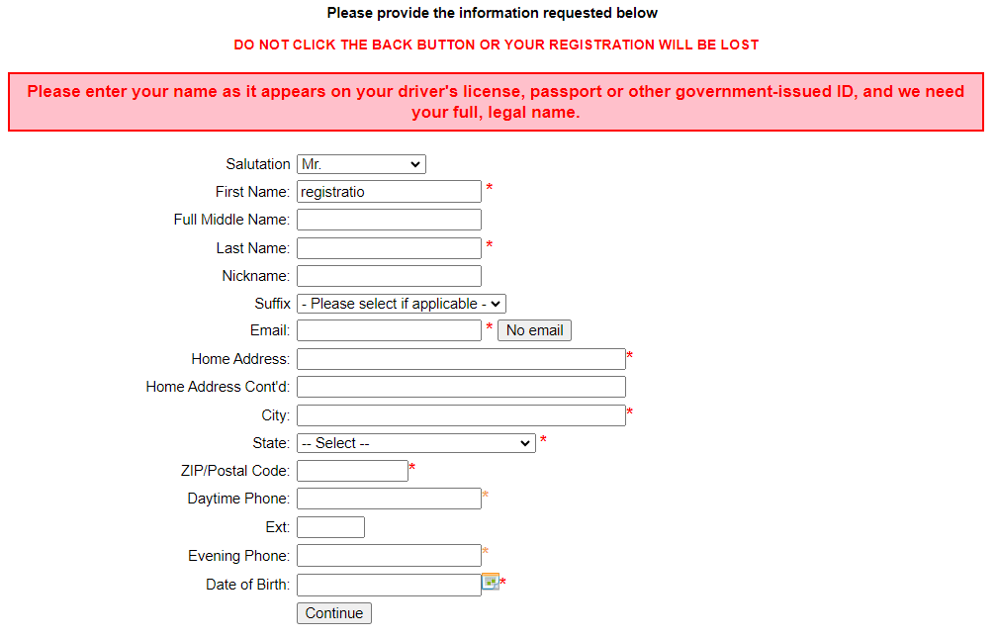
Select the PRIMARY location where you work or volunteer by clicking the downward arrow and highlighting the location.  Click Continue to proceed.  Note: If you serve at multiple diocesan locations, you will be prompted to select those additional locations in future screen(s). | 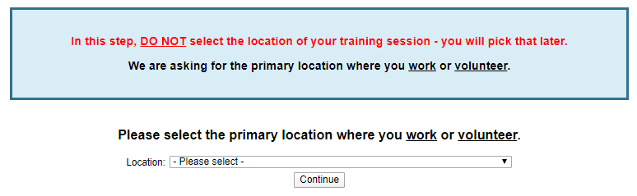
Your selected location(s) are displayed on the screen.  Select the role(s) that you serve within the Diocese of Winona - Rochester and/or parish/school. (Use descriptions supplied, to help determine appropriate role(s) to select.)  Please check all roles that apply.  Click Continue to proceed. | 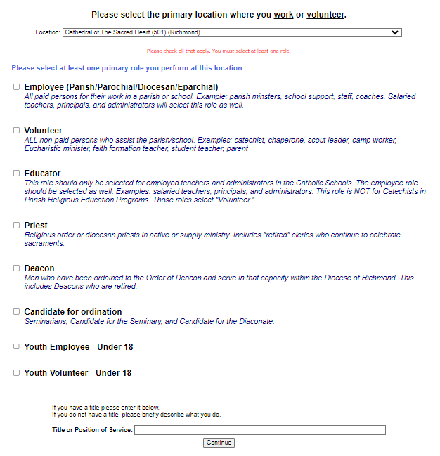
Please select Yes if you have any additional locations or click No to continue. | 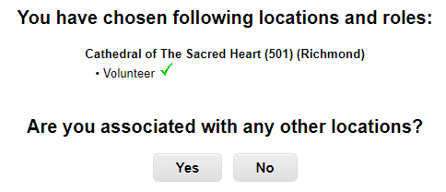
Answer the questions. | 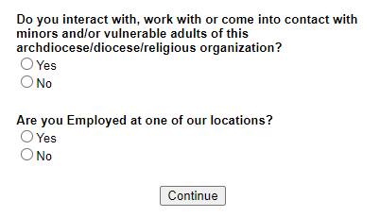
Please review and acknowledge you have read the following document:  - Diocese of Richmond Code of Ethical Conduct  To proceed, please Confirm by clicking on: “I have downloaded, read, and understand the Code of Conduct” and enter your full name and today’s date.  Click on Continue. | 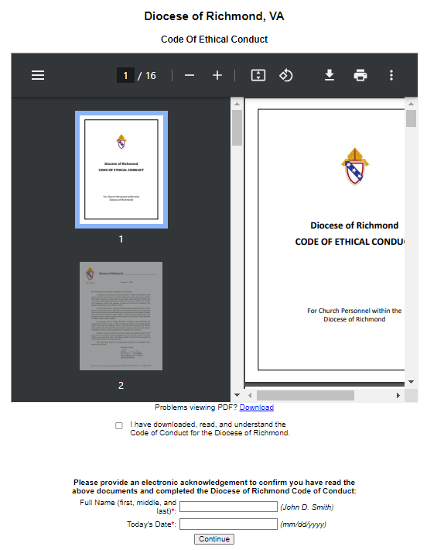
Please review and acknowledge you have read the following document:  - Diocese of Richmond Digital Communications and Media Policy  To proceed, please Confirm by clicking on: “I have downloaded, read, and understand the document above” and enter your full name and today’s date.  Click on Continue. | 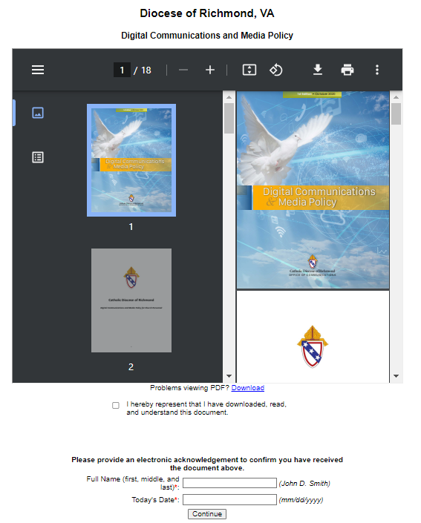
Please review and acknowledge you have read the following document:  - Diocese of Richmond Safe Environment Regulations  To proceed, please Confirm by clicking on: “I have downloaded, read, and understand the document above” and enter your full name and today’s date.  Click on Continue. | 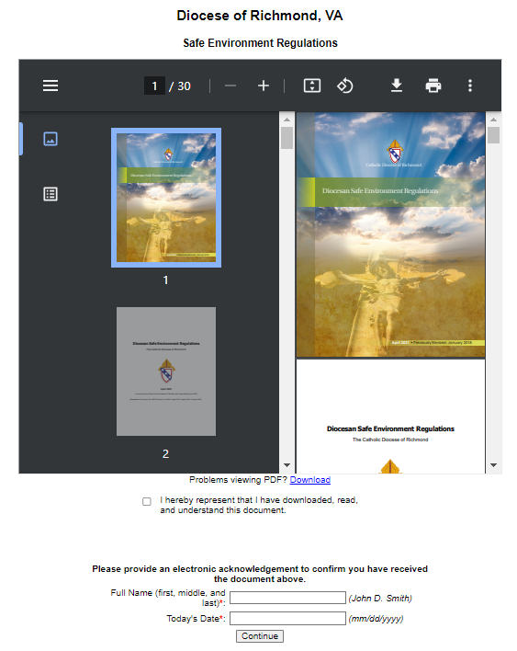
If you have not attended a VIRTUS Protecting God’s Children session, choose NO.  Otherwise, choose YES. | 
To complete your VIRTUS registration, your final step is to sign up for an instructor-led Protecting God’s Children® training session from the schedule provided.  Select the session you wish to attend (click the circle) and click Continue to complete your registration and return to your VIRTUS Online account. | 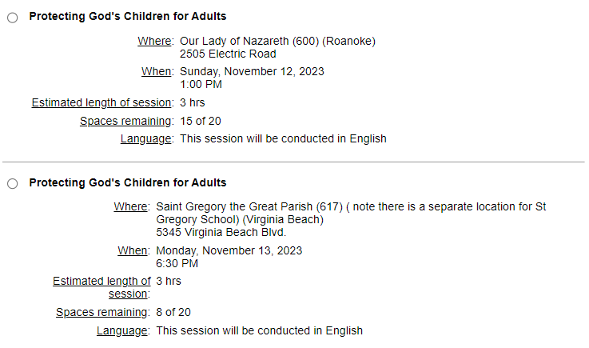
You must now complete a background check. Click on the link that says “Submit Background Check” to complete your background check. | 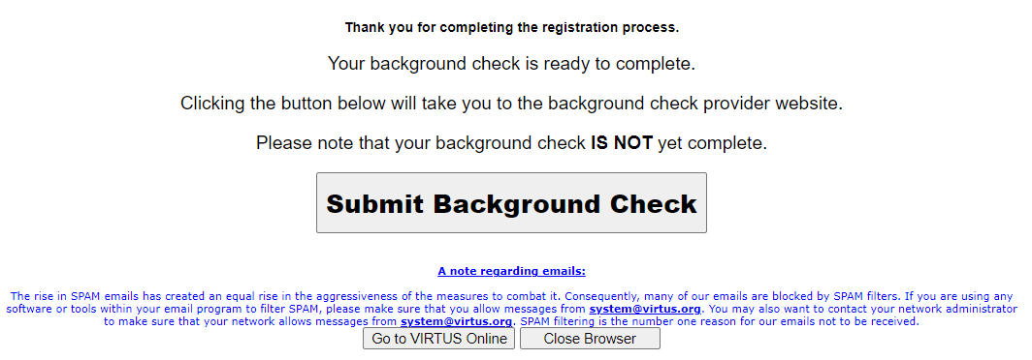
Once you have registered for a training session and completed your background check, you can log back into VIRTUS.  If you need to change the training session you selected, just click on “You are registered for a session” to update your session. | 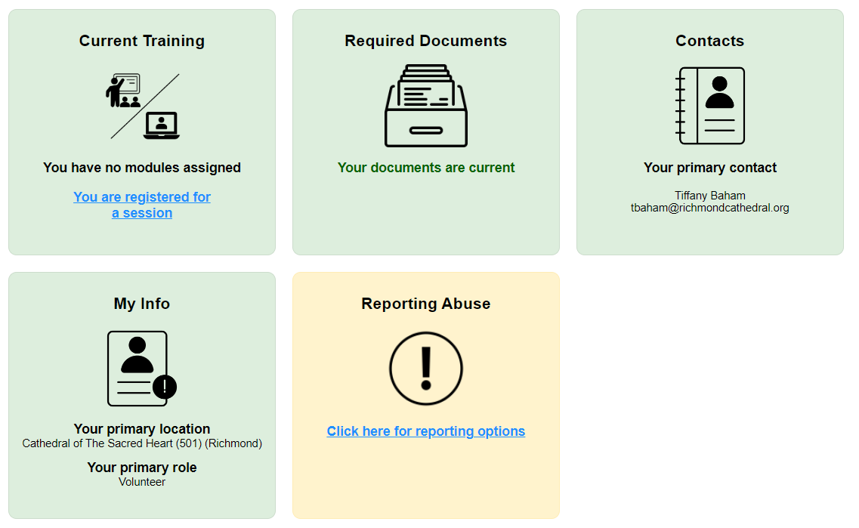
If you have additional questions about VIRTUS Online training, please contact the VIRTUS Help Desk at 1-888-847-8870. | 

